Brunswick Community Sports Club submission
Moreland City Council - draft advertising provisions

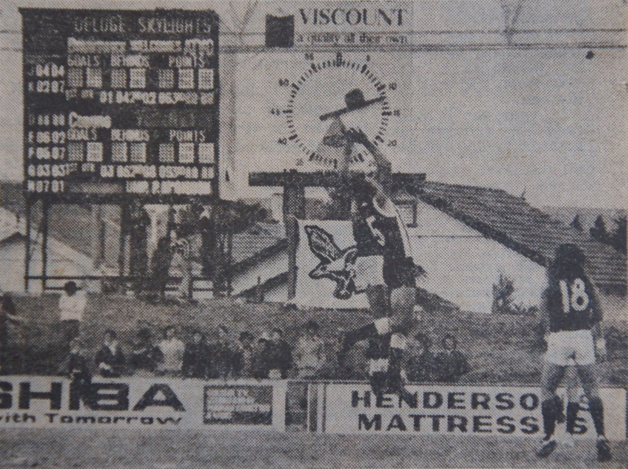
Sunday 18 April 1976 - opening round VFA match between Brunswick and Coburg at Gillon Oval

Submission

- The provisions of clause 52.05 Advertising Signs of municipal planning scheme across Victoria only became law under the Victoria Planning Provisions (VPP’s) in late 1997 after local government amalgamation.

- It is unknown whether local government chose to exercise control over advertising signs within sporting and recreation facilities up until this point of time, which explains the reason why many of the sporting grounds had sponsor signage located around the inside of sport fields, arenas, typically affixed to the fence (facing inwards), scoreboards and other buildings.

- Advertising signage has been part of the Australian football, cricket landscape and indeed part of the aesthetic environment of sporting fields for over 100 years.

- The use of sporting and recreation facilities for recreation/sport etc. does not require a planning permit, while the ancillary functions of providing food and drink, car parking, social clubrooms and sponsors signage over many decades, means that these facilities have existing use rights.

- This also applies to use of land or building for a sign, as signs are defined as a “land use”, with various signs defined under clause 52.05.

1.2 Existing use rights

- All planning schemes in Victoria have existing use right provisions, which are identified at clause 63.01.

Extent of existing use rights
An existing use right is established in relation to use of land under this scheme if any of the following apply:
- The use was lawfully carried out immediately before the approval date.
- A permit for the use had been granted immediately before the approval date and the use commences before the permit expires.
- A permit for the use has been granted under Clause 63.08 and the use commences before the permit expires.
- Proof of continuous use for 15 years is established under Clause 63.11.
- The use is a lawful continuation by a utility service provider or other private body of a use previously carried on by a Minister, government department or public authority, even where the continuation of the use is no longer for a public purpose.

- The general principles applying to existing use rights (Shire of Perth V O’Keefe, 1964) held that there was sufficient evidence to establish the applicant existing use rights in that the reserves had been used as a major sports ground for the purpose of playing football matches and for training since prior to the introduction of planning controls. The lighting of the ground for football training did not change the purposes for which the reserves were used and existing use rights applied.

- This principle was also applied in Royal South Yarra Tennis Club v City of Prahran (1985) and Essendon Football Club v City of Moonee Valley (1997).

- The use of social club rooms is as much part of the use of a major sports ground as is, for the example, the use of the changing rooms and as such no permit is required. (Collingwood F.C. V City of Collingwood 1992).

- Hence all recreation facilities that existed prior to say 1997 when the VPP’s were introduced into the Moreland City Council have existing use rights under the first point and/or where proof of continuous use for 15 years has been established.

- Later development of new outdoor recreation facilities, since say 1997 would however not enjoy these rights.

1.3 VPPs & clause 52.05

- It is identified that the exemptions under clause 52.05-4 Signs not requiring a planning permit, identify that these provisions do not apply to major recreation and recreation facilities, providing the advertisement cannot be seen from nearby land.

- A major recreation facility is defined under the planning scheme: Land used for leisure, recreation or sport, and where there is substantial provision made for spectators, such as a grandstand, and to which spectators are usually charged admission.

- Hence major recreation facilities such as Gillon and Coburg City Oval would be exempt under clause 52.05 given the provision of major grandstands. No doubt there would be other facilities within Moreland CC that would also enjoy this exemption.

- Further sponsors signs attached to the inside of a boundary fence cannot be seen from nearby land, given the presence of fencing, landscaping, bunding and buildings (grandstands).

- Therefore most sporting grounds within Moreland would enjoy existing use rights and the requirements of clause 52.05 do not apply.

- Section 8 of the report deals with “key findings” and sub-section 8.1.1 Inventory of signs now needs to be substantially revised in light of the issue of existing use rights of the various sporting facilities within Moreland.

- A revision of this report would also apply to sub-section 8.2.1 and 8.2.10 which identifies that 520 sponsor and club name signs would have to be removed.

1.4 Other exemptions - clause 52.05 Advertising Signs

- Exemptions under Clause 52.05 of the Moreland Planning Scheme state

A sign with an advertisement area not exceeding 5 square metres publicising a local educational, cultural, political, religious, social or recreational event not held for commercial purposes. Only one sign may be displayed on the land, it must not be an animated or internally-illuminated sign and it must not be displayed longer than 14 days after the event is held or 3 months, whichever is sooner. A sign publicising a local political event may include information about a candidate for an election.

- This exemption is typically applied to say “registration days” notifying the public of the enrolment of players for upcoming seasons in various sports.

- This sign is identified in the draft policy as a “club member/player sign”.

- The typical time period would be 4 weeks prior to the event and maybe left in place for a further 2 weeks, to give parents/players who may have missed out on viewing the sign and opportunity to register.

- This system works wells as the signs are prepared by specialist companies on instruction by the club/sponsor and placed on site by a provider with experience in the installation of signs. The removal thereafter is also undertaken by the same installer/company.

- There is no need to for this system to be altered, or a new system proposed, while the exemption applies all municipalities in Victoria and cannot be amended or changed to a lesser provision by the Council. i.e. a By law.

- These types of signs can also be displayed on residential properties and indeed on other sites.

2.0 Other Issues

- Much of the report is focus on the views of Council officer with anecdotal evidence. It is unknown what or how the contents of the brief for this consultancy were derived, other than the referral of this issue being raised in a Council report of 2013.

- There is a conflict here within the report, in that municipal staff is being asked for their views about signage, yet their professional focus can only be on the planning or legislative process. Of course they will want to propose a new planning regulation or process, that’s what their position requires.

- Hence the content of the report and its recommendations focus on the implementation of a new process for signage, with token consultation with Clubs.

- This is a major flaw of the report giving officers of the council more weight than the Clubs, while the discussion under “council staff” and the identification of issues appears to be anecdotal.

- The report is very general in its findings and adopts the expression of “some” in describing the presence of advertising signs. There is no photographic evidence.

- The use of this term “some” appears in Sections 3 and again in Section 4.1, yet it is notes that the report states that “There are no significant problems with the signs”.

- The description that some events signs are “inappropriately designed” and too much of the sign is covered in sponsor’s information lacks specific details.

- I would doubt whether a local Real Estate Agent is going to formulate a sign for an event for a sporting club, (which the company is sponsoring) and then cover it in the Estate Agency details, given that their signs proliferate throughout the municipality in selling or renting homes.

- What the sponsor and club seek is acknowledgement of their connection with the club and the notification of the event (i.e. registration day).

- In terms of anecdotal evidence, why is an event such as a “trivia night” deemed as “minor”? The purpose of the sign is to raise awareness for raising funds and would not be considered minor from the clubs perspective.

- Further the recommendation then states “to limit the types of activities that can be promoted through an event, club member/player and club activity signs”.

- How is this to occur? Application is made to place on a sign on a park for a fund raising Trivia Night and the planning officer says NO, as this “type of event” is to be discouraged? A sign is a sign and the event identified on the panel is of no concern to the Council.

- Further the draft policy recommends that the new policy should balance the revenue generation interests of the sporting clubs and community organisations with protecting community safety and visual amenity.

- Given that the recommendations focus on using the Planning & Environment Act 1987 as the regulatory mechanism, the issue here is that “revenue” cannot be used as a factor in counter balancing community safety or visual amenity.

- If the “counter balance” to revenue is the limitation on the area of signs, then no investigation has been completed by this report with respect to quantifying the revenue impacts on imposing any limit in advertising area.

2.1 Section 8.2.4 Permitted locations

- Clearly the starting point here is that the inside of every oval and enclosure (i.e. tennis) is able to display signage. There can be no visual or aesthetic impact with signs placed on the inside of the boundary fence, displayed to both players and patrons. This would also include time keepers, interchange shelters, scoreboards and the like.

- This form of advertising has been commonplace throughout the sporting history of Australia. The common dimensions being fence height (1-1.2m) x 3-5 metres in length, where a mesh fence is provided or a longer dimension to fill in between the posts.

- We fail to see how a sign on a tennis fence or cricket net enclosure should be prohibited?

- The issue of signs causing damage hung on fences and sprinkler noise is also anecdotal. If damage did occur then the Club would be responsible for the rectification to make good.

- In terms of the extent of signage, the report then identifies that only 50% of the playing field fence should be set aside. What research is this figure based on?

- Is there an example where a ground has MORE than 50% of the perimeter covered in signs and where the visual amenity of the recreation areas is considered prejudiced or compromised?

- How can perimeter fencing sponsor signs, signs on scoreboards, pavilions etc. which have been part of the sporting landscape for over 100 years, be considered visually intrusive?

- In terms of “Club name signs”, much is made of this issue, yet these should be standardised across the municipality and the name signs should be erected by Council on all entries into reserves.

- Not only to facilitate ease of access for opposition teams, but also to facilitate identification of access and egress for ambulances.

- Where larger facilities have multiple grounds and club buildings, standard Council signage should be erected to facilitate identification.

- There is no research that identifies how the recommended 20% coverage area for sponsor information for a community activity sign was derived. The recommendation is anecdotal and based around the observation “that it appears reasonable”.

- This nonsense continues with the recommendation that club activity signs that promote junior sport such as Milo Cricket, Tennis Hot shots etc. should be limited. This approach is at odds with the need to promote sport to junior players at a time when obesity across the adult and children population is increasing.

- In terms of duration of signs (8.2.7) how is a Milo Cricket sign considered appropriate for 4 weeks but is then considered detrimental or has a visual impacts within the 5th week? None of this makes any sense.

2.2 8.2.9/8.2.11 Permit/approval process

- The balance of the report deals with the issue of changing the planning scheme to deal with signage issues. This appears to be based on what other councils have completed in the metropolitan area, although it is unknown whether or not the issue of existing use rights was examined in any of these municipalities.

- For those recreation facilities without existing use rights and the need to apply for a planning permit, is clearly not a solution for the following reasons.

  - It is well known that all planning departments in Victoria cannot deal with planning application in an expeditious manner that would be suit the circumstances of new sponsors being attracted to a club each year prior to the playing season.

  - The recent “Vic Smart” planning application process, introduced by the State Government for minor applications are also performing poorly, with numerous examples of applications going over time. A recent example where a planning permit for a subdivision application of an existing building which should take 7 days and was approved in 45 days by a municipality!

  - The average time for the processing of planning applications in the metropolitan area is 150 days, which would represent most seasonal playing seasons. Clearly this timeline would be prejudicial to the attraction of sponsor for all sporting clubs.

- The Local Government response would be that a dedicated officer and a “fast track” process be implemented to expeditiously deal with these applications. Bureaucracy and the administration of rules and regulations is never about making decisions quickly.

- The decision guidelines of clause 52.05 are extensive and numerous and for a lay person/club to prepare a planning application and provide an explanation against these provisions, is beyond most people’s capability.

- Further an application for planning permit will require:

  - Copy of title (even though it’s a council reserve - $30);
  - Three (3) coloured plans of the advertisement (allow $300);
  - Site plan for the location of the sign(s) (Cad plan – not hand drawn);
  - Application fee of $102;
  - Town planning submission demonstrating compliance with both clause 52.05 and the “signs in open space” policy;

- In terms of processing an application, Council would advertise all applications, especially those that may face outwards or maybe seen from outside the perimeter of the facility/ground.

- Allow for $3-500 depending on the number of owners/occupiers notified, 14 days exhibition and for consultation meetings to be held to consider objections.

- The culture of local government is that some change must be seen to be made to justify the process and the decision, whether objections are received or not. So the original application plans for the sign(s) would need to be amended requiring additional costs.

- Clearly this process is both expensive and not timely and does not suit the requirements of not-for-profit sporting clubs.

2.3 The solution – Clause 52.03 Specific site & exclusions

- Given that existing use rights apply to recreation grounds within Moreland, built prior to 1997, then for those facilities built after this date, should also be exempted from the planning scheme.

- This can be achieved through the listing of these reserves/facilities under clause 52.03 Specific site & exclusions. This clause allows municipalities to exempt site from planning controls.

- The location and extent of signage (m2) within these reserves can be completed as part of an overall plan that would be completed by the sporting club as part of this exemption.

A search of planning permits for signs at the recreation facilities would be required.
Installation of lights at Windy Hill
A weasel word (also, anonymous authority) is an informal term for words and phrases aimed at creating an impression that a specific and/or meaningful statement has been made, when only a vague or ambiguous claim has been communicated, enabling the specific meaning to be denied if the statement is challenged.
.Ambulances still can’t find Gillon Oval and continually travel up and down Victoria or Hope Streets
Council would consider that such a sign may have a cause “material detriment” under Section 52 of the Planning & Environment Act

